Title of Lesson: Body to Body Big Idea: Water and Communities’ Relationships Grades: 7-8
Enduring Understanding
Water is essential to the growth and livelihood of the communities surrounding it. Societies become dependent on water as they develop, using it for agriculture, industry, travel, etc. As time goes on, this balance of water and human life changes, as human priorities and actions change. Additionally, this relationship looks different depending on the community. Specific resources are provided by certain bodies of water, thus creating issues and experiences. Examining these individual relationships leads to cultural, ecological, and progressive understandings of water and its relationship to community.
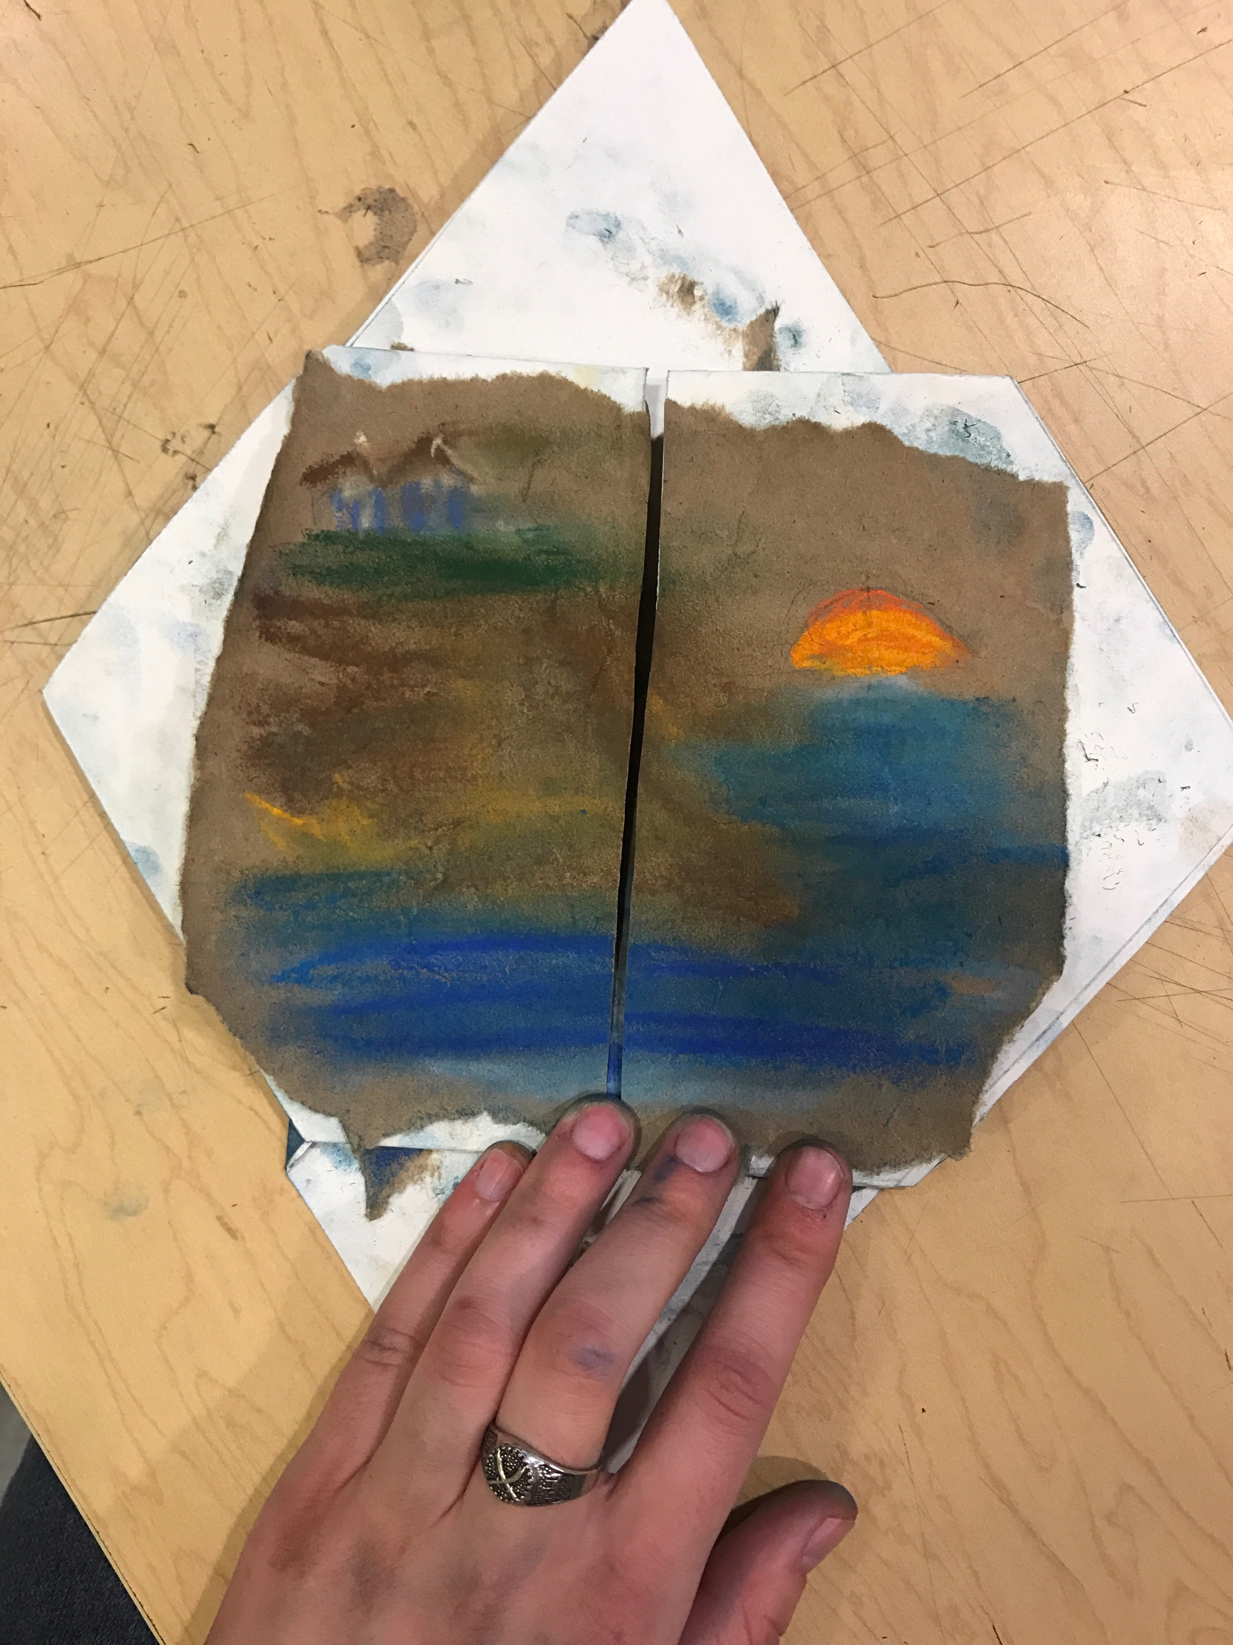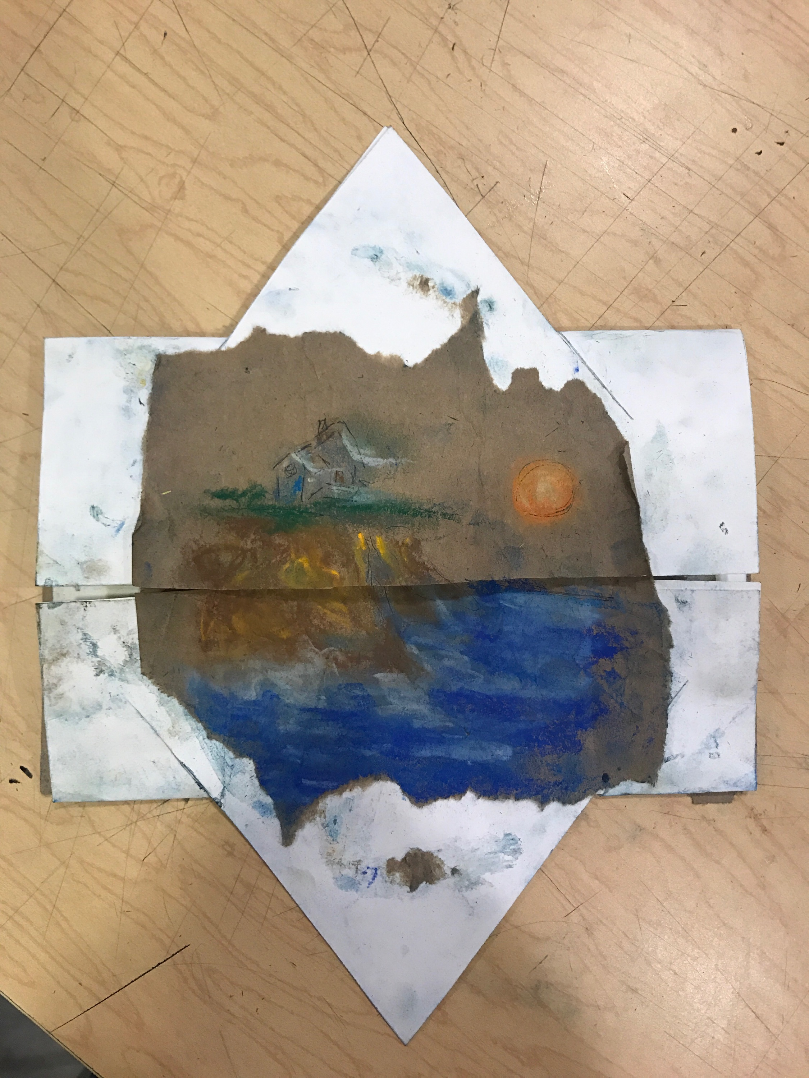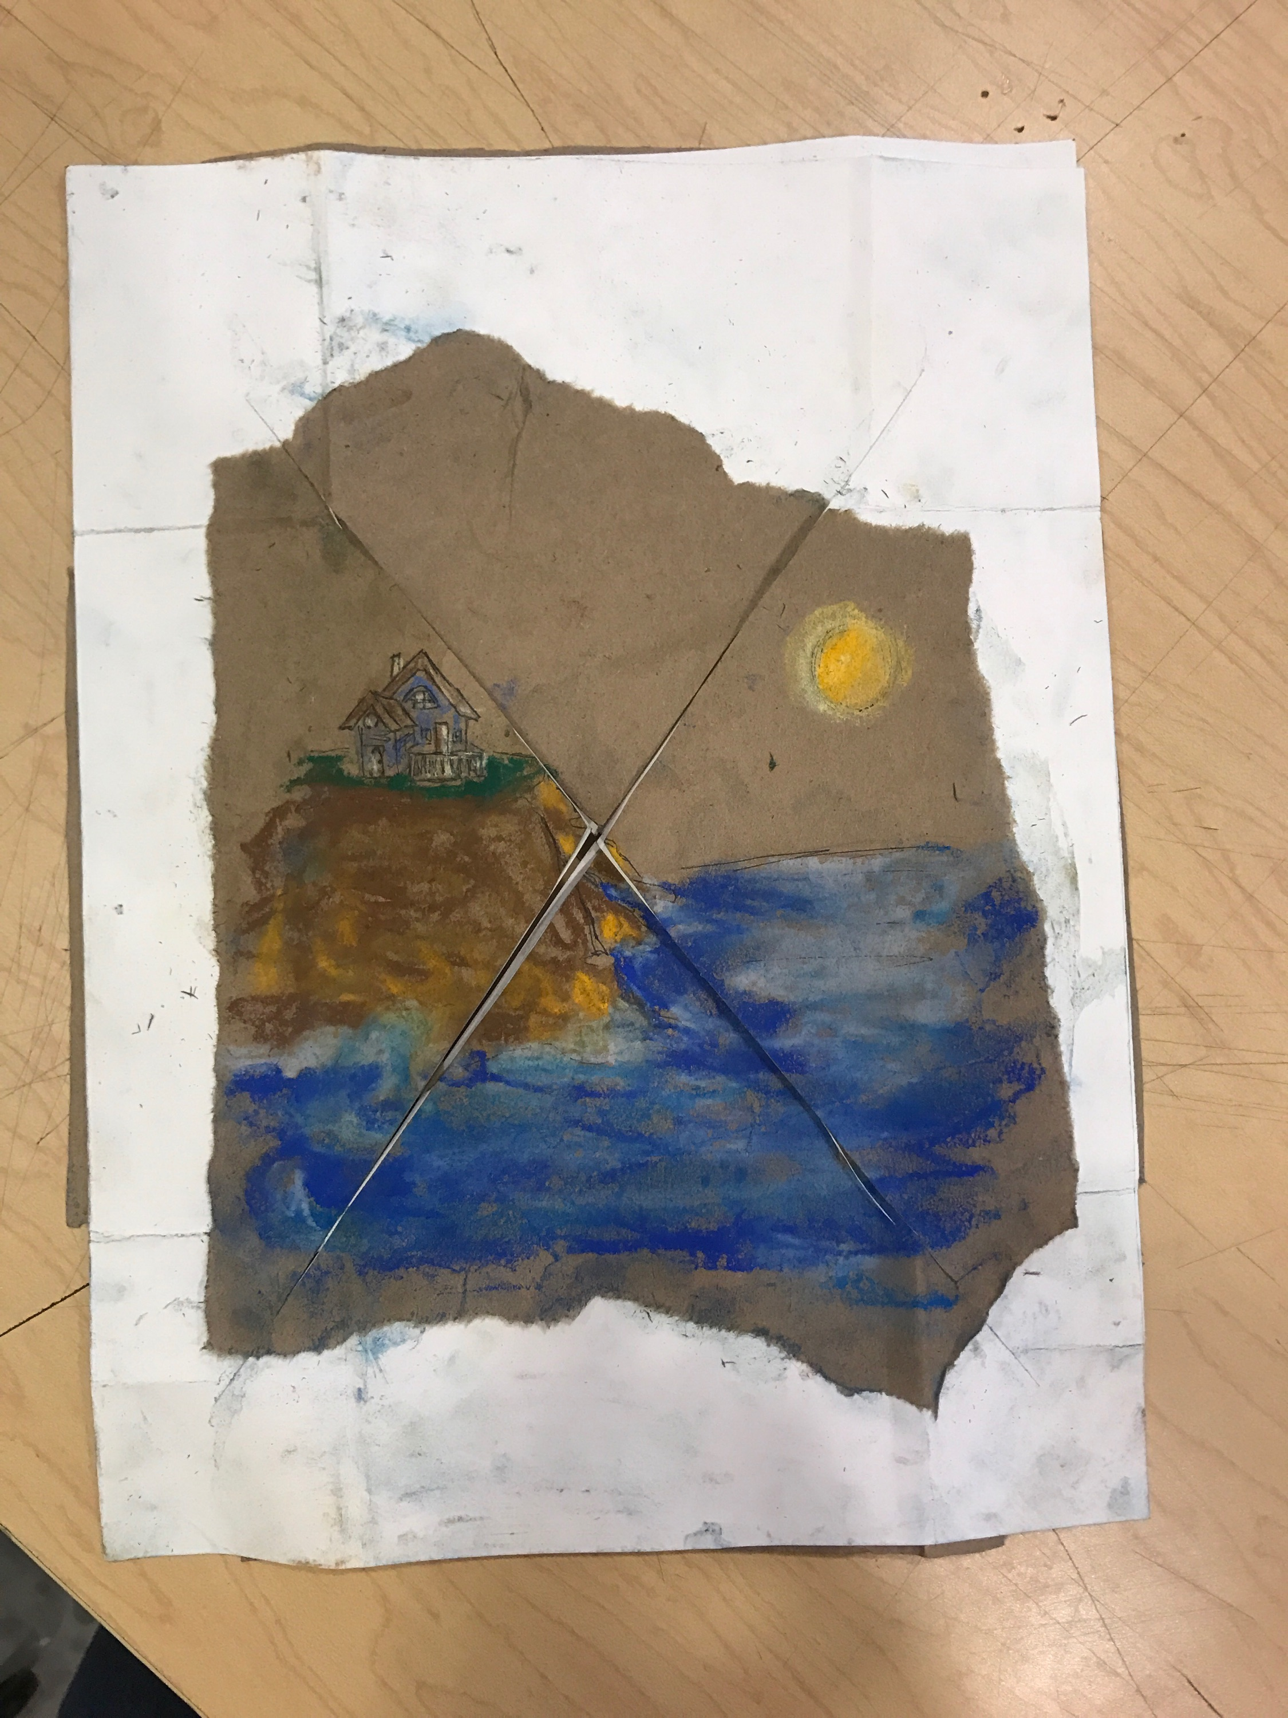
Structural Example
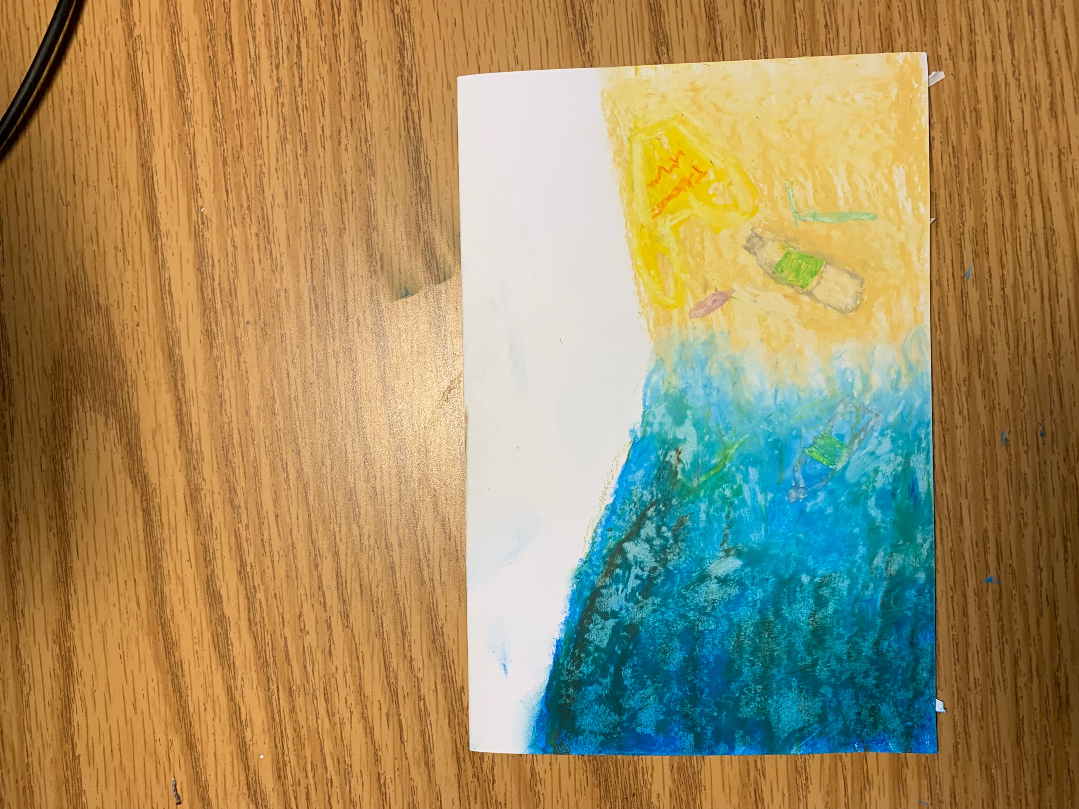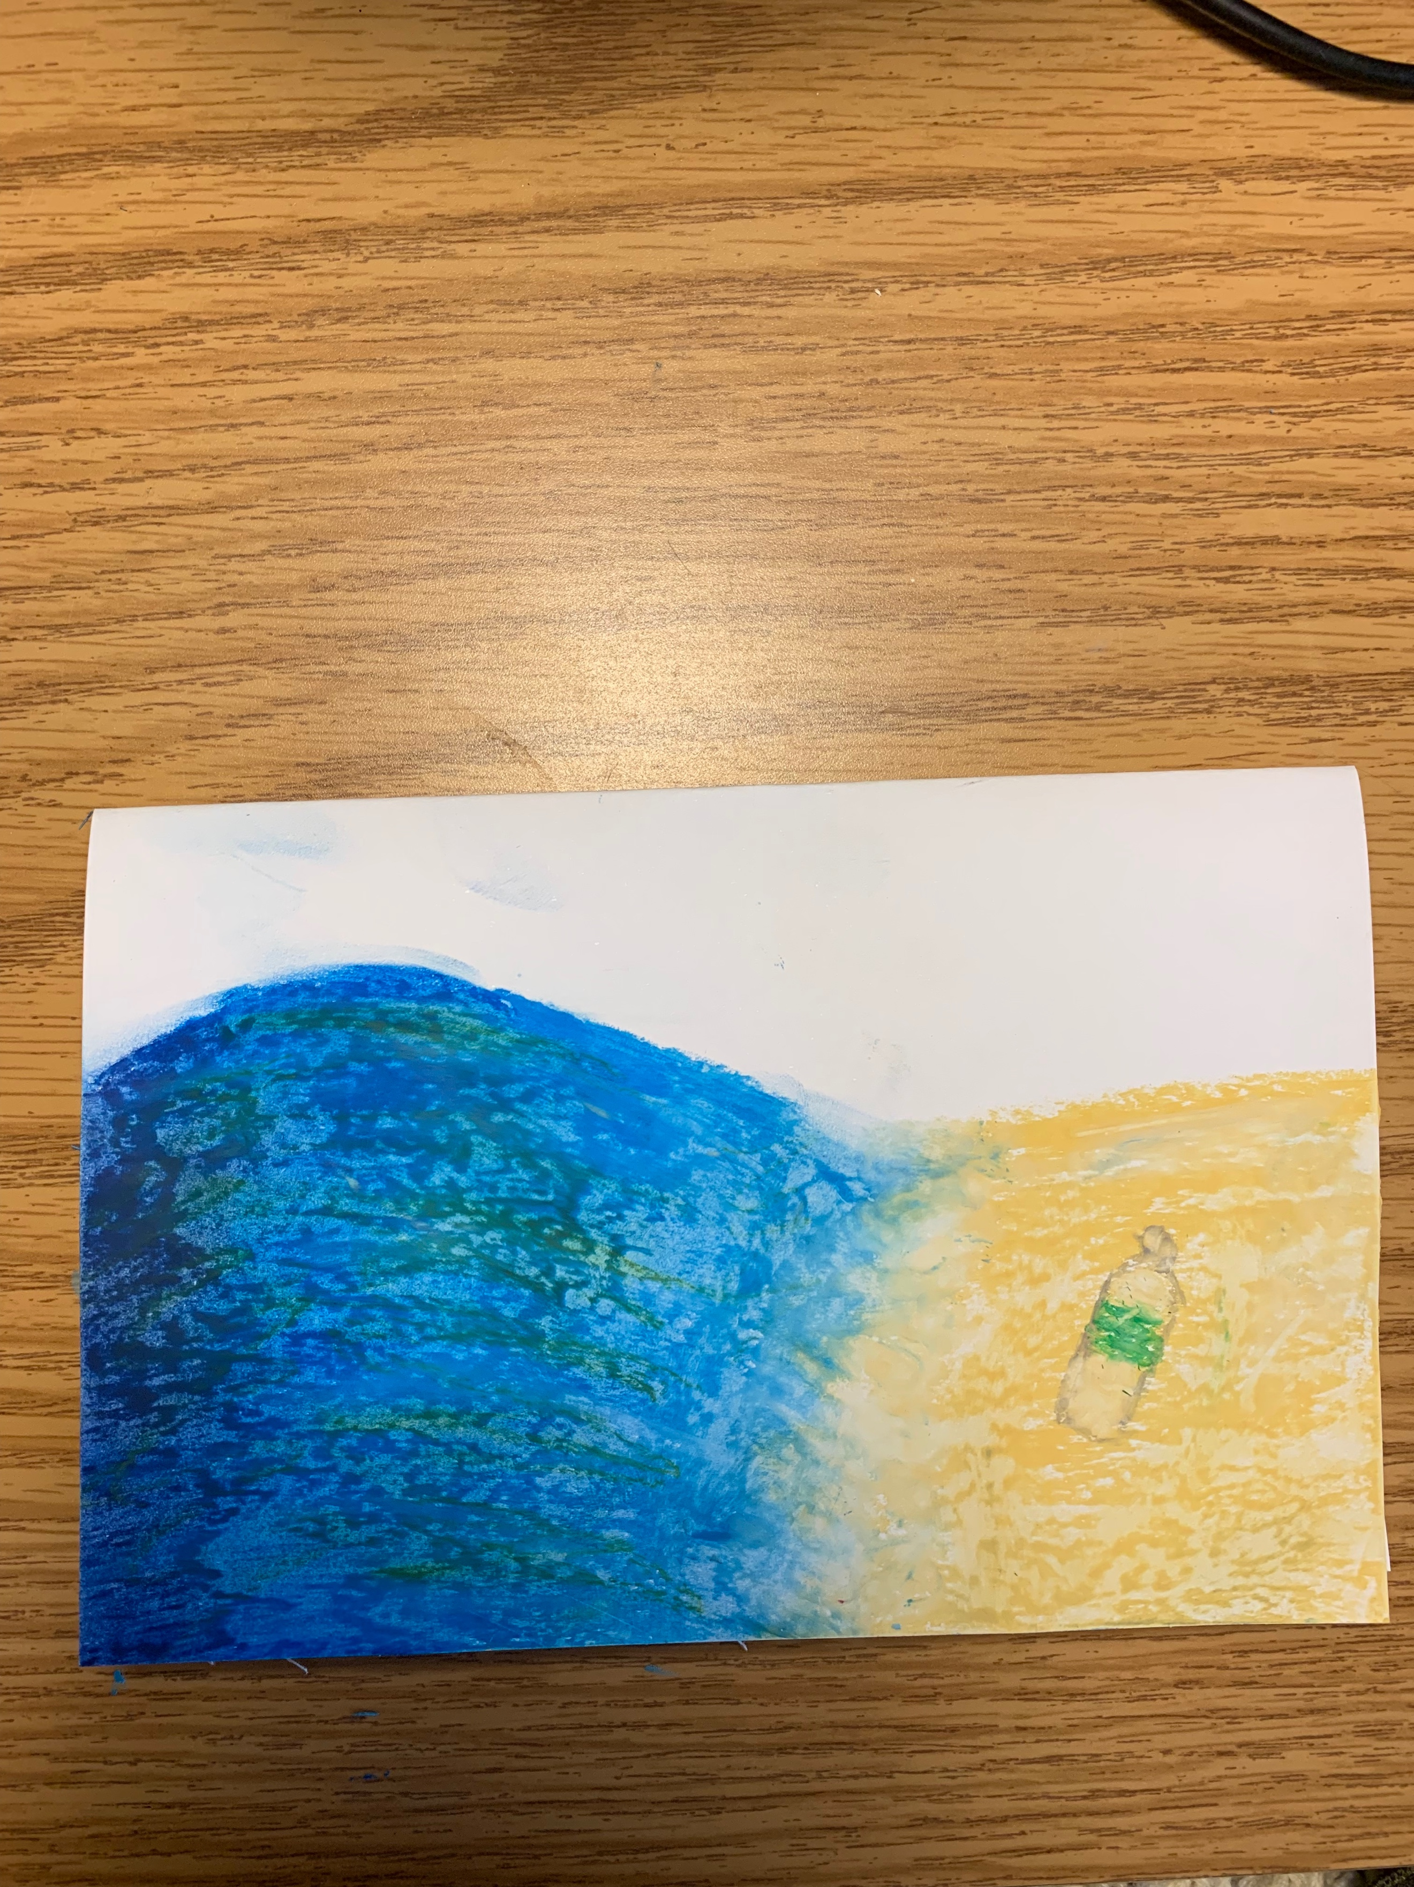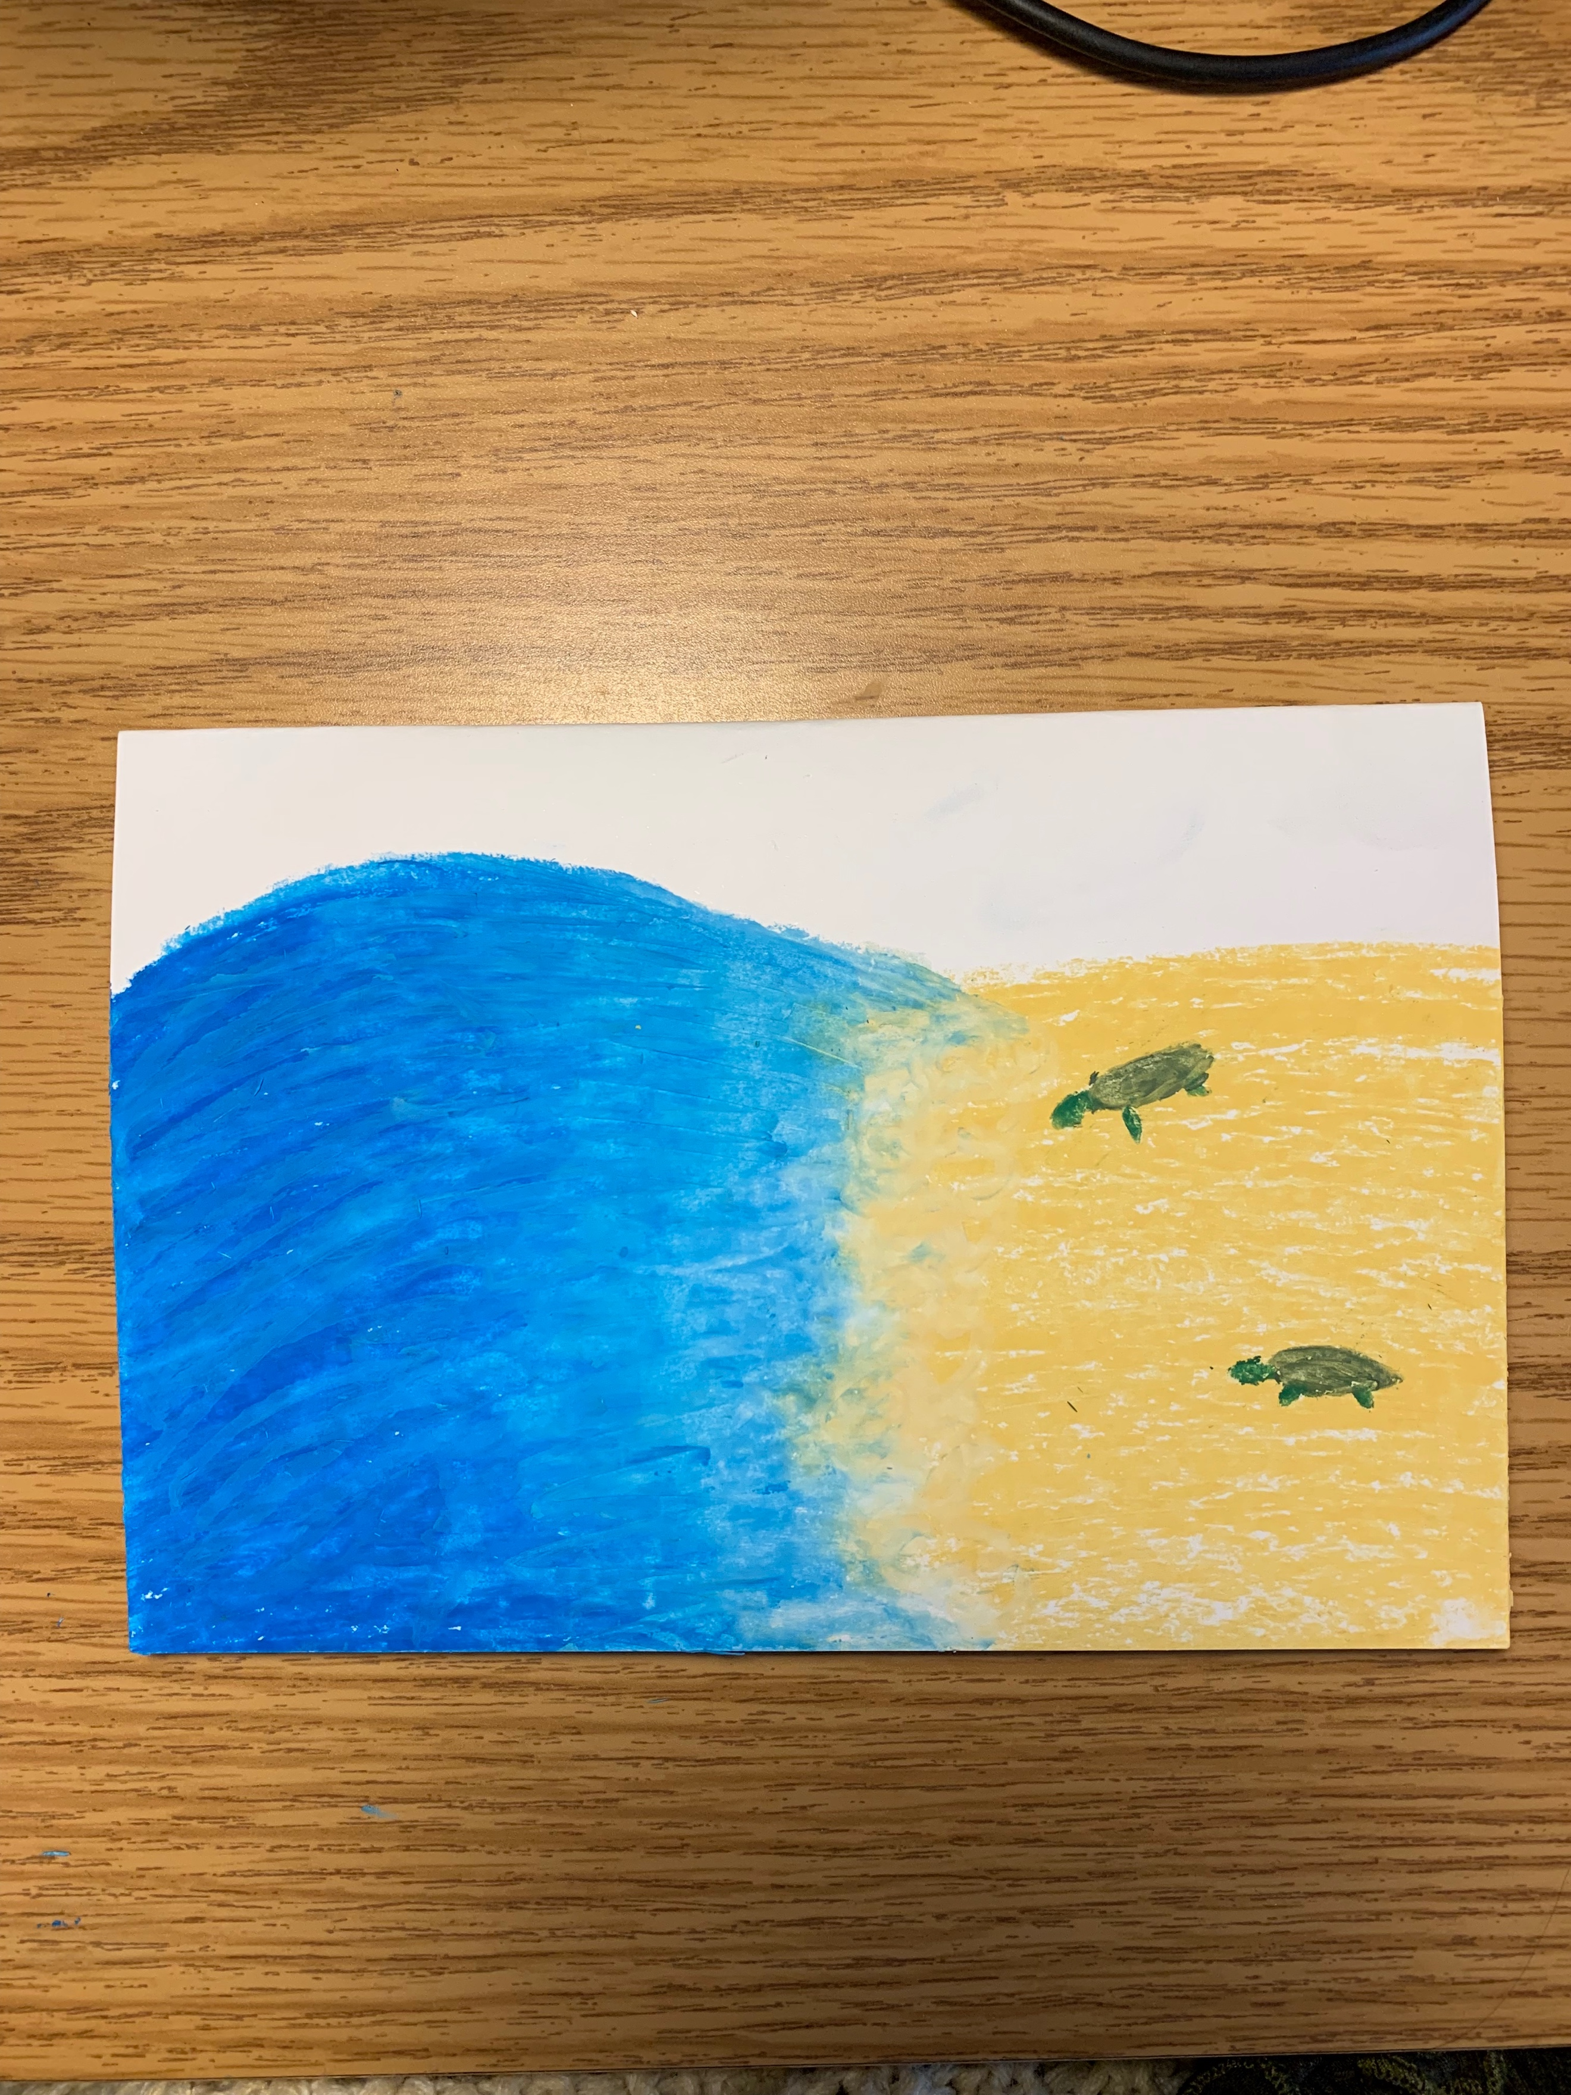
Illustration Example
- How do people use water?
- What effects does water have on economy, industry, everyday life, etc.?
- How do people affect the water ecosystem?
- How does location influence this relationship?
- How does this relationship continue to change?
Central Focus
Activities Sequence
This lesson will provide students with knowledge of imagery and symbolism through artist exemplars and in class instruction. They will then research a local body of water and use that knowledge and their knowledge of symbolism to construct an informative visual of an environmental issue facing that body of water.
Day 1: The students will be introduced to the big idea of water and communities’ relations. They will then be conducting a guided research about their local body of water in groups of 2-3.
Day 2-3: The class will review research from last class and pick their body of water issue. A presentation on symbolism will be shown. An introduction to the project will be conducted and students will begin sketching ideas.
Day 3-4: Students will construct their flexagon after a demonstration. They will then continue to sketch and plan their ideas.
Day 4-5: Students will begin to draw onto their flexagon.
Day 5-6: Students will begin to finalize their flexagons.
Day 6-7: Students will discuss and present their flexagons.
Essential Questions
Exemplar Artwork

- Pencil
- Ruler
- Cardstock paper
- Scissors
- Glue Stick
- Colored Pencils/Oil Pastels/Pastels/Markers

- The student will use research to develop a basic knowledge of issues regarding the Delaware River.
- The student will be able to represent an issue into symbolic imagery from artist examples.
3. The student will apply their knowledge of symbolic imagery to create an informative flexagon.
4. The students will be able to explain the progress of their issue and justify its influence on the surrounding community through presentation of their flexagon.

Objectives
Materials

New Jersey Visual Arts Standards:

1.3.8.D.2
Content Statement: Themes in art are often communicated through symbolism, allegory, or irony. There are a wide variety of art mediums, each having appropriate tools and processes for the production of artwork. Fluency in these mediums, and the use of the appropriate tools associated with working in these mediums, are components of artmaking.
Indicator: Apply various art media, art mediums, technologies, and processes in the creation of allegorical, theme based, two and three dimensional works of art, using tools and technologies that are appropriate to the theme and goals.
- aligned with Objective 3

1.4.8.A.5
Content Statement: Symbolism and metaphor are characteristics of art and art-making.
Indicator: Interpret symbolism and metaphors embedded in works of dance, music, theatre, and visual art.
- aligned with Objective 2

National Visual Arts Standards:

VA:Cr1.2.8a: Collaboratively shape an artistic investigation of an aspect of present day life using a contemporary practice of art and design.
Enduring Understanding: Creativity and innovative thinking are essential life skills that can be developed.
Essential Questions: What conditions, attitudes, and behaviors support creativity and innovative thinking? What factors prevent or encourage people to take creative risks? How does collaboration expand the creative process?
-aligns with Objective 1

VA:Cr2.3.7a: Apply visual organizational strategies to design and produce a work of art, design, or media that clearly communicates information or ideas.
Enduring Understanding: Artists and designers balance experimentation and safety, freedom and responsibility while developing and creating artworks.
Essential Questions: How do artists and designers care for and maintain materials, tools, and equipment? Why is it important for safety and health to understand and follow correct procedures in handling materials, tools, and equipment? What responsibilities come with the freedom to create?
-aligns with Objective 3

VA:Re.7.1.7a: Explain how the method of display, the location, and the experience of an artwork influence how it is perceived and valued.
Enduring Understanding: Individual aesthetic and empathetic awareness developed through engagement with art can lead to understanding and appreciation of self, others, the natural world, and constructed environments.
Essential Questions: How do life experiences influence the way you relate to art? How does learning about art impact how we perceive the world? What can we learn from our responses to art?
-aligns with Objective 4

By Olivia Egnatovich & Megan Scarborough

