Title: Creature Conservation Targeted grade level: 5-6th grade Big Idea: Conservation of Marine Life

Central Focus The 5th and 6th grade students will gain an appreciation of marine life and develop a sense of conservation
through their art-making materials. They will start their first lesson with guided research of animals they feel a personal
connection to and participate in class discussion of their findings. Students will create a design for their chosen animal and
then proceed to execute the design by using recycled materials of their own choosing. Recycled materials will help them
become more conscientious of their consumption of materials that are harmful to marine life. Students will collaborate to
assemble a mural of their marine animal designs. They will then participate in a class critique and discussion in a way that
assesses how their knowledge influenced their art.

Objectives
- The student will be able to identify problems facing marine animals by conducting research and completing research log. (2)
- The student will be able to apply the elements of design to their own animal project using mixed media. (3,4,5,6)
- The student will be able to collaborate effectively with groupmates by working together to create a mural. (6)
- The student will be able to connect material choice and how it impacts their artwork by experimenting with different materials. (3, 4, 5, 6, 7)

Standards
1.3.8.D.1 Content Statement: The creation of art is driven by the principles of balance, harmony, unity, emphasis, proportion, and
rhythm/movement.
Indicator: Incorporate various art elements and the principles of balance, harmony, unity, emphasis, proportion, and rhythm/movement in the creation of two- and three dimensional artworks, using a broad array of art media and art mediums to enhance the expression of creative ideas (e.g., perspective, implied space, illusionary depth, value, and pattern).
Our objective states that students should use design elements to create a work and the standard above outlines the design elements students will use. (Objective 2)

1.3.8.D.6 Content Statement: The visual possibilities and inherent qualities of traditional and contemporary art materials (including digital media) may inform choices about visual communication and artmaking techniques.
Indicator:Synthesize the physical properties, processes, and techniques for visual communication in multiple art media (including digital media), and apply this knowledge to the creation of original artworks.
In our objective we expect students to be more conscientious of materials, and by using recycled materials they will contemplate upon the impact each material has in their work. (Objective 2)

1.2.8.A.3 Content Statement: The arts reflect cultural mores and personal aesthetics throughout the ages.
Indicator: Analyze the social, historical, and political impact of artists on culture and the impact of culture on the arts.
Students will look at the movement of artists who are inspired by environment issues, the materials they are using, and how these materials relate to their own projects. (Objective 4)
Exemplar Artworks:
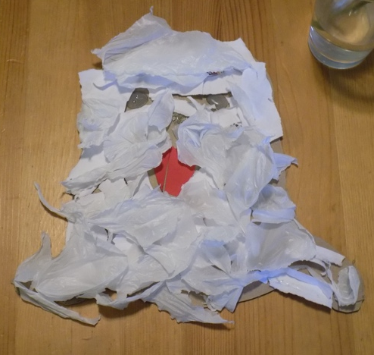
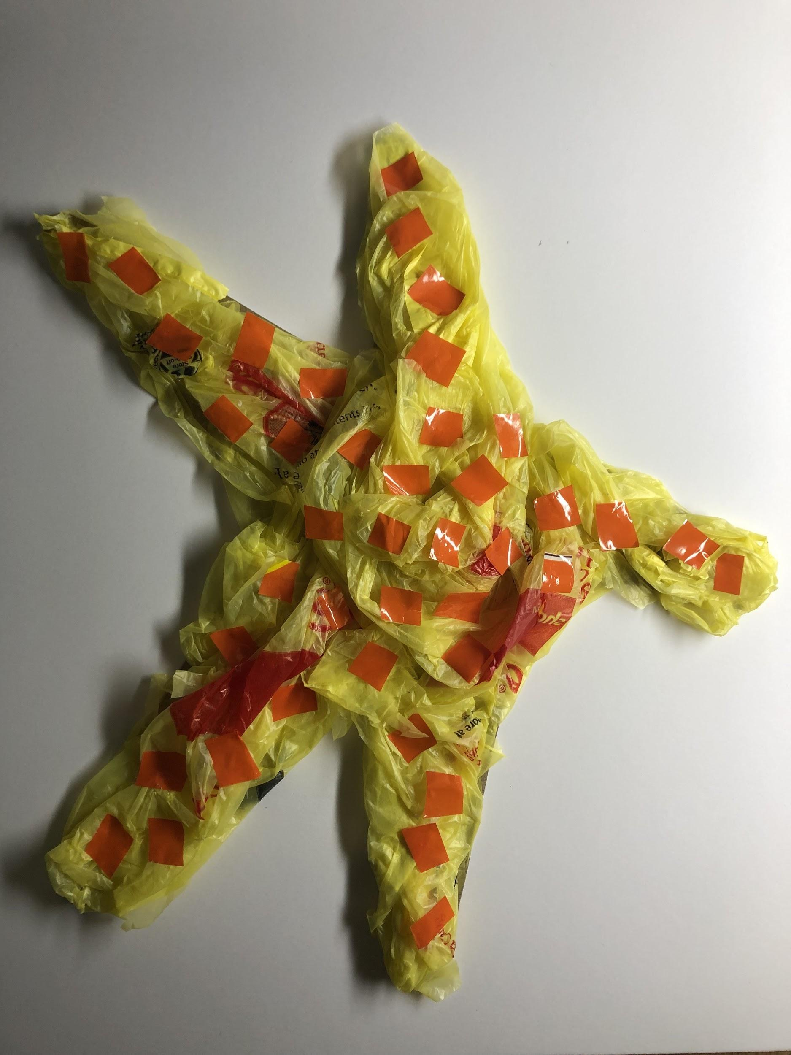

Essential Questions:
- Why should we care about ocean animals?
- What can we do to help the animals?
- Where is your personal connection to the ocean?
- How do our actions affect marine life?
Enduring Understandings: Conservation of marine life means being mindful of how we use our resources, treat our
environment, and preserve marine animals. By having children learn about the importance of marine life conservation,
teachers begin to prep children towards a mindset that allows for the younger generation to feel empowered to take control
of their own futures. This lesson plan will stoke compassion towards marine life and show how they can help their favorite
animal from home. Encouraging these personal interests, like a student’s favorite animal or trip to the beach, will allow for
greater understanding and active learning. Exploring student choice through use of materials will also create a more authentic
learning connection. This lesson should instill hope for a better future for the environment and emphasize the children’s
agency in making a change for the better.

Materials : Student choice of recycled materials, Glue, Tape, Cardboard sheets , Scissors, Acrylic paint, Brushes, Cups

Vocabulary : scale, microplastics, conservation, mindfulness, marine

Summary of the Sequence of Activities
Day 1: Introduction to big idea and marine life through short documentary clip. Students will play Stac-King
Game,m which will also be used as a pre-assessment. Students will pick a creature they want to research and
conduct their research as homework.
Day 2: Students will bring in homework and discuss their creature in groups of three based on the same creature
that they all picked. Students will then present findings to the rest of the class as a means of teaching each other
the information featured in the game.
Day 3: Students will visit the Eternal Springs gallery show and learn about the different artworks and how they
relate to their own project. During the gallery visit, students will be able to play the Stac-King game and see if
they can answer more questions correctly than they did the first time. Students will have a homework assignment
to bring in materials from their homes.
Day 4: Students will be introduced to the project and be asked to repurpose their materials towards the design of
their sea creature in whatever way they choose. Muted ocean documentaries will be playing in the background
while students work as a means to inspire them.
Day 5-6: Class will start with a short recap about the big idea of marine conservation, and facts about their
marine animals. Students will continue working on their animal. During the class there will be a video playing of
different marine animals to inspire the students.
Day 7: Students will collaborate to create a mural using their own animal designs and the teacher-created
background.
Day 8: Students will critique their mural and discuss how the various recycled materials changes the meaning of
their work.

By Alyssa Shoenfelt & Jenna Sokolik

