Lesson Segment Title: Pollution in water and us! How we can change the world through small actions, and become water warriors.
Big Idea: Personal responsibility and its effect on the environment.
Grade Level: 3-4 Class: Visual Art Making Lesson Segment Duration: 4 Days
New Jersey Visual Art Standards:
- 1.1.5.D.2: Compare and contrast works of art in various mediums that use the same art elements and principles of design.
- 1.2.5.A.1:Recognize works of dance, music, theatre, and visual art as a reflection of societal values and beliefs.
- 1.3.5.D.5:Collaborate in the creation of works of art using multiple art media and art mediums, and present the completed works in exhibition areas inside and outside the classroom.
- 1.4.5.A.3:Demonstrate how art communicates ideas about personal and social values and is inspired by an individual’s imagination and frame of reference (e.g., personal, social, political, historical context).

Enduring Understanding:  It is important as individuals to understand that our actions, no matter how small, have a wide-spread impact in our interconnected world. Environmentally speaking, our individual choices to recycle directly affects whether or not our water becomes polluted and marine life suffers. It is important for students to be self-aware and understand that their actions at home have a wide environmental impact so that they can make conscious decisions. Self-awareness will in turn allow students to become responsible global citizens that make changes for the good of local and global environments. | Essential Questions:  -How are our individual choices to recycle important in the bigger picture?  -How can our actions at home make a difference to our community?  -Do we have a responsibility to marine life that is both local and global?  -Why are our attitudes towards water pollution important?  -Why should we be self-aware?
Objectives:  1. The student will be able to identify causes of water pollution and how personal choice can affect global ecologies by developing research of a contemporary artist and a written personal reflection.  2. The student will (be able to) demonstrate understanding of shape, form, colour, and materials by constructing a cohesive sculpture based on a researched causes of pollution and the animals it affects.  3. The student will be able to apply research of marine habitats to create informative installations made of recycled materials.  4. The student will be able to interpret and reflect on eco based artworks based on applied materials and integrate themes of personal responsibility and global citizenship into their personal lives. | Central Focus: The central focus of this learning segment is to encourage students to use spatial design to fortify information from the big idea. Students will be using different materials in a tactile manner that will help them visually understand the concept of space, modeling, and form. Students will be able to process shape and design and make decisions based on the environment they are working in.
Sequence of Activities:  Day 1. Students will start by getting a brief overview of the big idea and given the essential questions. After looking at eco related artworks/ artists, students will be broken down into their groups and begin researching marine animals that their group decides on based off of a large list of endangered animals impacted by water pollution. For homework, students will be asked to begin collecting recycled materials for their group animal.  Day 2. Students will play a game designed to help them understand the importance of recycling and have them think about their actions on a daily basis. This game will help drive students towards developing personal connections to the Big Idea. Second half of the class should go towards group discussions on materials they have started to collect and how they want to design their animal.  Day 3. Students will spend the day working on their marine animal as a group. Since the students are working on either one large or a few small examples of their animal, one day should be enough for the actual building of the sculpture.  Day 4. Students will finish their work and will spend the day putting together their marine habitat as a class and discussing how their choices affect these animals. Students will be asked again to answer the essential questions from the beginning of the class and will write out a personal reflection as homework. | Student Examples:  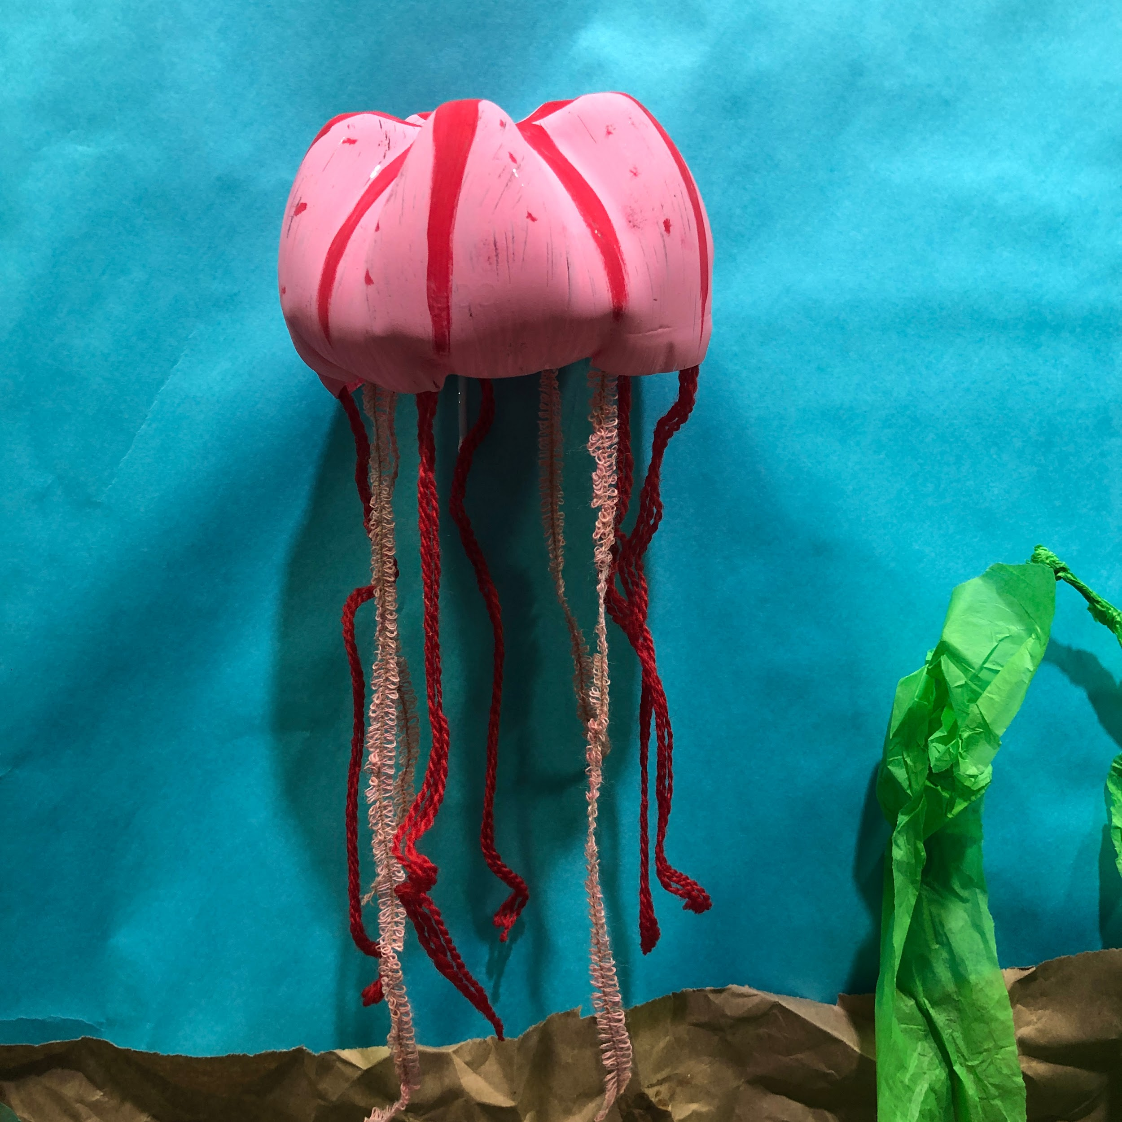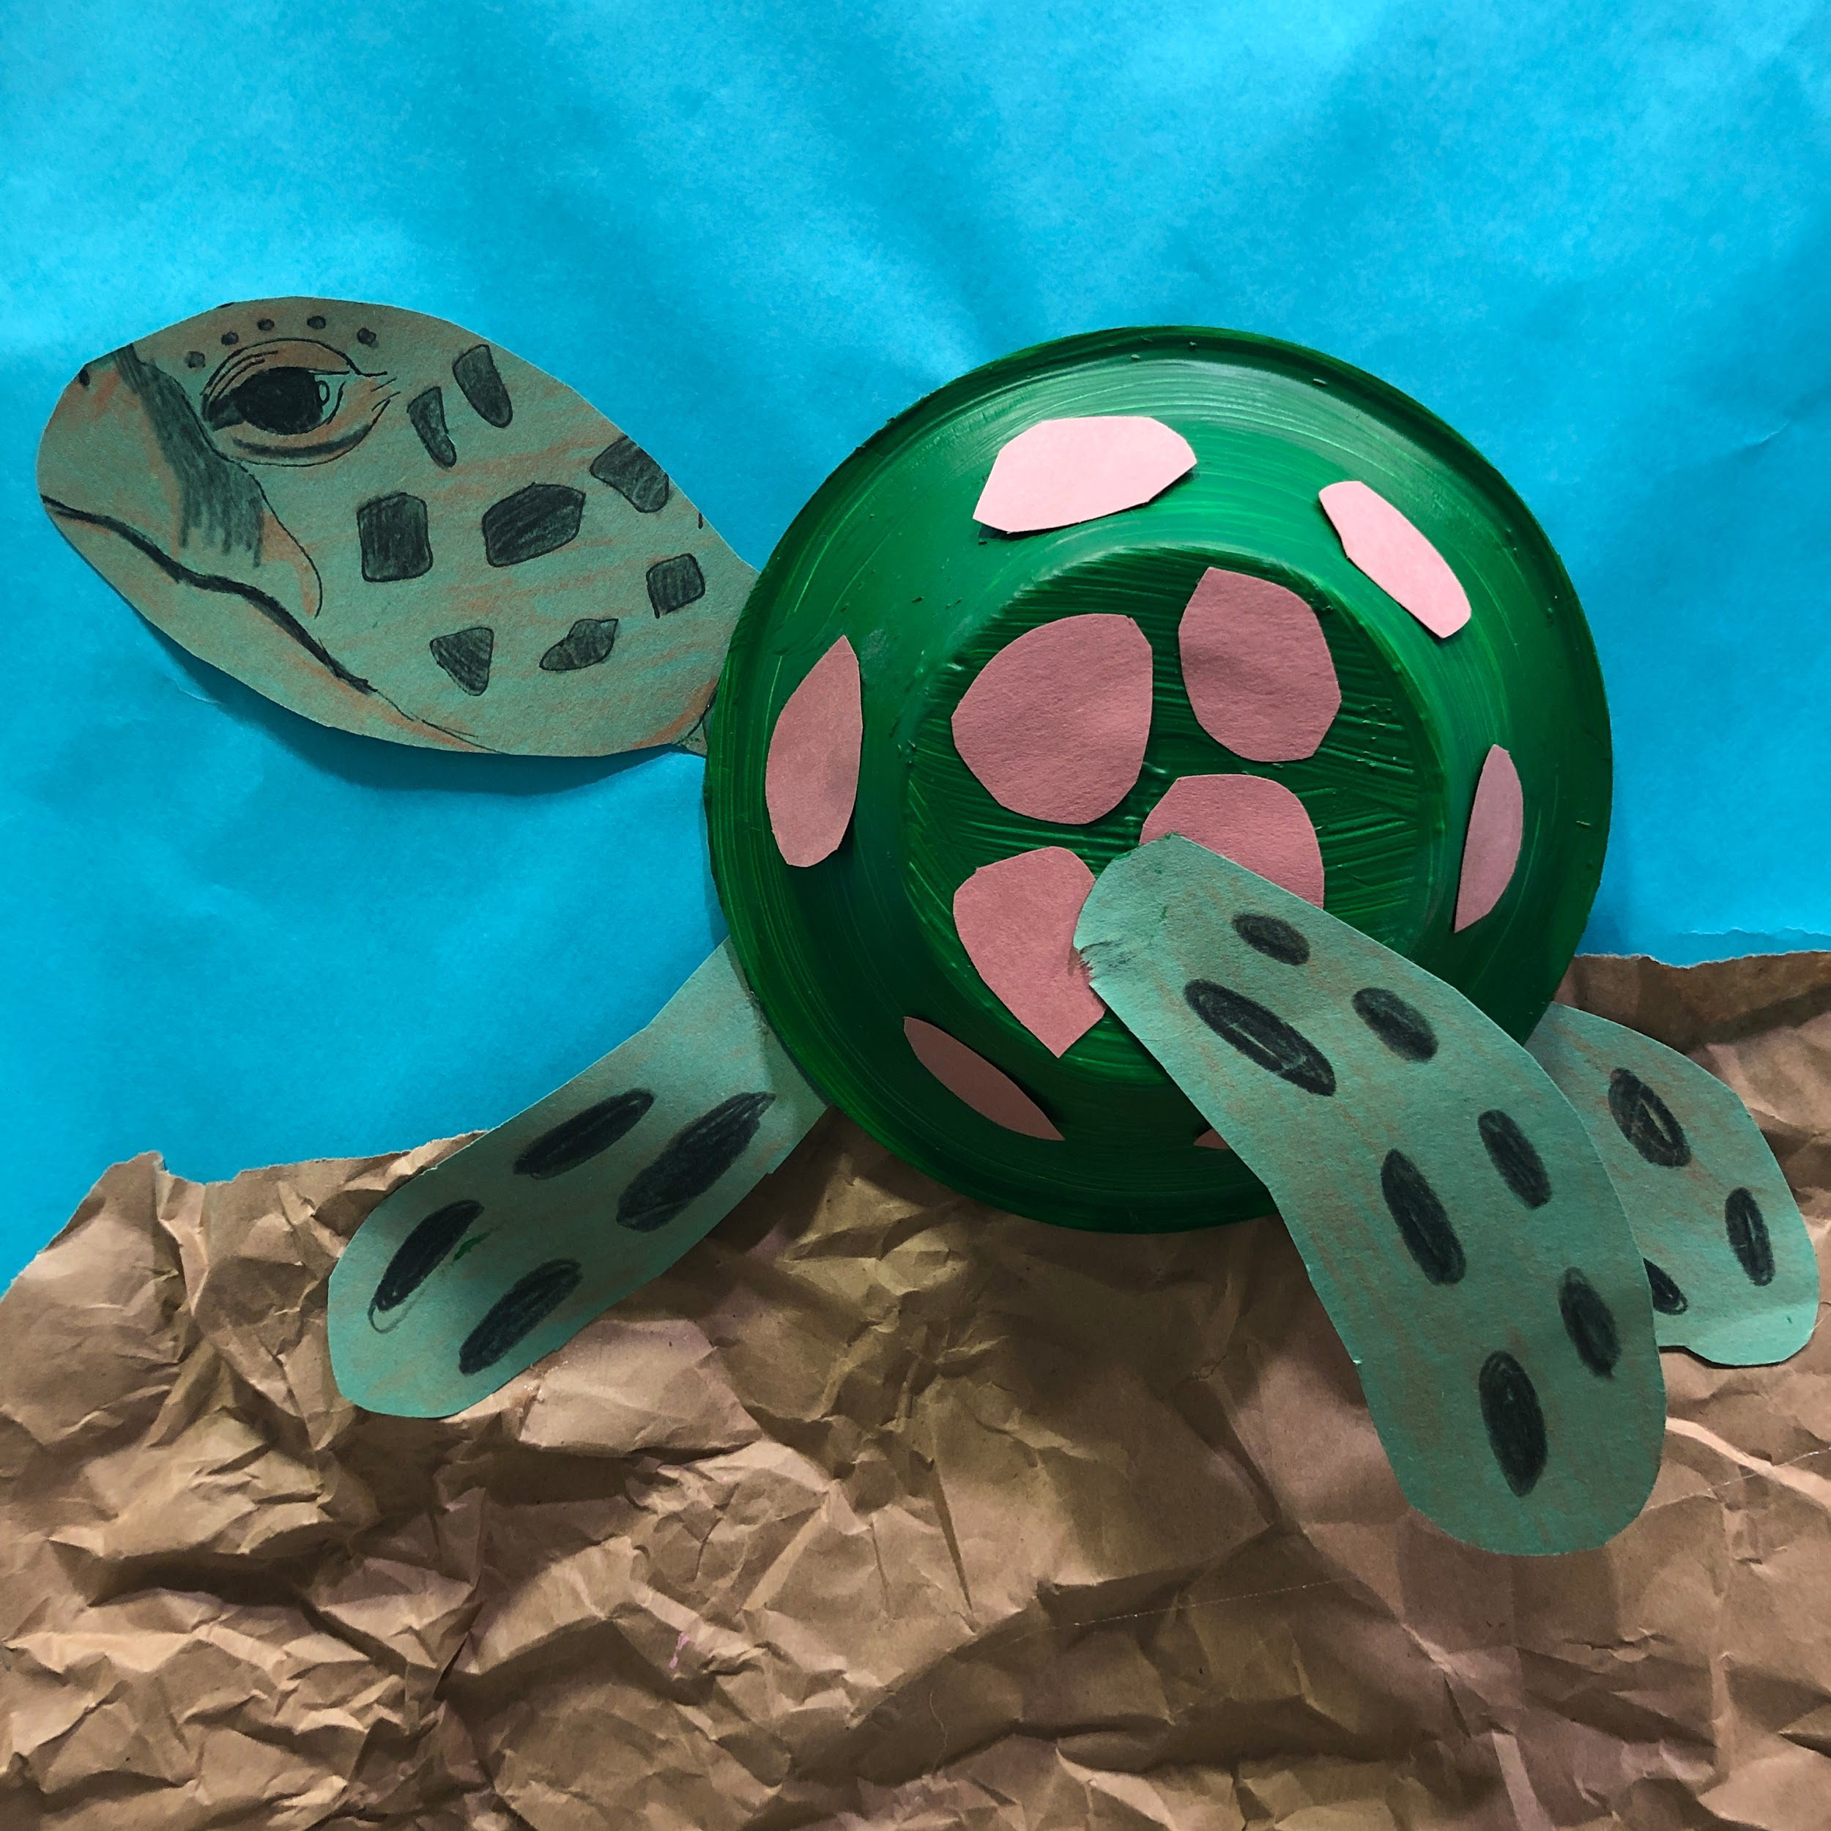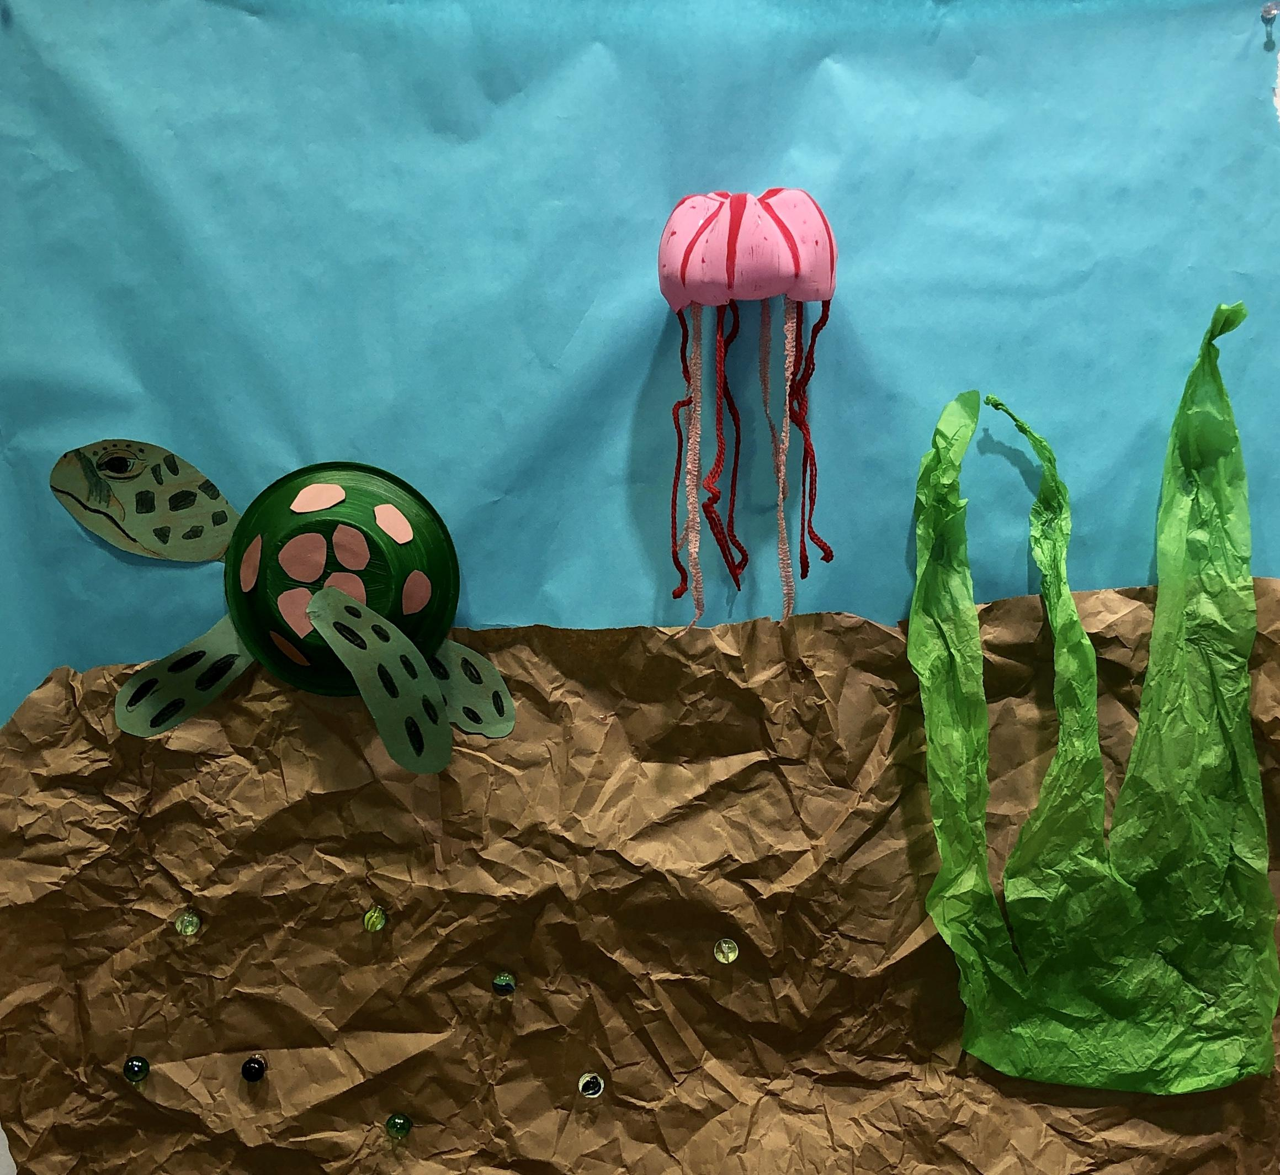
Materials:  -Recycled materials from home (includes cardboard, plastic bottles/ cups, plastic bags, styrofoam, tissue paper, wrapping paper, ribbon, marbles)  -Elmers Glue  -Large rolls of paper (blue or purple)  -Tempera Paint  -Brushes  -Construction paper  - Crayons/ Markers | By: Erica Gavzy and Tori Oshel

